Notes on AWS – Solutions Architect Associate Exam
Types of exams rated with difficulty
- CCP
- solutions architect
- sysops
- developer associate
- security specialty
- advanced netowrking speciality
- devops pro
- solutions architect pro

Exam blueprint
130 min in length
60 – 80 questions
passing score needed: 720/1000
valid for 2 years.
Scenario-based questions – SIMILAR TO COMPTIA AND ISC

History of AWS
Chris Pinkham and Benjamin black presented a paper on internal infrastructure.
Business case – selling extra computing power to others.
First service SQS – Simple queue service – 2004
AWS – launched in 2006
2007 over 180K developers on the platform
2010 – Re:Invent conference for AWS developers
2013 certs launched.

AWS – 10000 Foot Overview
AWS global infrastructure
There are 19 regions, 57 availability zones.
Availability zones are a bunch of data centers in a close physical proximity of one another.
Region – has 2 or more AZ.

Cloud Front – AWS’s CDN, It uses Edge locations, endpoints that cache content.
There are more than 150 edge locations.

Identity Access Management (IAM)
It allows you to manage users and their level of access to the AWS console.
Think of IAM as Active Directory

You can
- share access
- granular access – login with FB, gmail
- identity federation – use with AD, Facebook, LinkedIn
- has MFA2
- temp access to users/devices
- has password rotation policy
- supports PCI-DSS compliance
User – individual users
Power users – access to aws services except for management of groups and users
-all users are configured globally
Groups – can apply certain security settings to many uses
Policies – guidelines for how security settings should be applied, appear in JSON format
-all policies are configured for global use
Roles – create a role and assign to a resource, manage CIA to resources (e.g. read, read/write)

CloudWatch
You can setup alerts to notify you when resources are passed a certain threshold, costs are at a certain percent and other crteria.

S3 and CloudFront
S3 – Object storage – secure, durable, highly scalable storage, object-based storage
Read after write consistency – just means you can read the file after a successful upload
Eventual consistency – you’ll have to wait before reading the file you uploaded, overwrite specific
S3 schema – key value pair, version ID
- it can be under control lists, and is available for torrenting
It has 11 9s availability

Tiers of S3
Standard – normal, 11 9s of durability. 2 9’s availability
S3 – IA (infrequent access) – lower fees
S3 – 1 AZ, IA - `1 avaialbility zone, 1 infrequent access
S3 – RRS – Reduced Redundancy storage – 99.99 avaialability
s3 glacier – used for data archive,3 types – standard, expedited, bulk

How S3 is billed
Factors: storage amount, requests to that storage, storage management pricing (cost for tags), data transfer speeds, data transfer acceleration,

CloudFront - CDN Overview
Network of edge locations that are used to serve data faster, way to acccess data,
Origin – where the locations fetch their data
CloudFront can host any AWS service and non-aws origin server

How CloudFront is billed
Charged for clearing objects

S3 Lab Notes
Remember, S3 must have unique universal names.
Also, the permissions to the bucket must be set first, before you can edit the settings of each individual file.

Version Control Lab Notes
When deleting files with version enabled, a file will be saved as a delete marker.
Versioning can only be enabled or suspended.
You can integrate with lifecycle rules ‘
Versioning MFA delete can require MFA when deleting a file
Cross Region Replication Lab
All your doing is backing up your s3 bucket in 1 region to another.
After backing up, NO NEW FILES CAN BE READ IN THE NEW BUCKET
You must run these commands to view them from the CLI.
Install these tools
- curl "https://s3.amazonaws.com/aws-cli/awscli-bundle.zip" -o "awscli-bundle.zip"
- unzip awscli-bundle.zip
- ./awscli-bundle/install -b ~/bin/aws

After install run these:
- aws configure – enter in your access key and secret ID
- aws s3 ls – list out all your s3 buckets
- aws s3 cp – recursive s3://<origin-bucket> s3://<destination-bucket> - this will cp all files from1 origin bucket to the destination bucket

NOTE: When deleting files in the origin bucket, it WONT delete them in the destination bucket. This is an AWS security measure.
You cannot use daisy chaining.

Lifecycle Management – S3 – IA & Glacier Lab
Glacier – low cost archive option
This lifecycle management can be used with versioning. Applied to current and previous versions.
Set the transition or/and set it to expire objects in the glacier lab

CDN CloudFront Lab
Click get started in AWS console, select cloudfront.
Origin domain name is just the service you are hosting
origin -id -
Distribution – Web distribution and RTMP (media streaming)

S3 Security and Encryption
By default, all buckets are private. It used the phrase of least privilege. You start easing up access to this bucket
4 types of encryption
IN TRANSIT - ssl/tls
AT REST –
Service Side encryption –
- uses s3 managed keys, EACH OBJECT HAS ITS OWN KEY , use AWS-256 encryption - SSE-S3
- AWS KMS – Managed keys- SSE-KMS, provides an audit trail
- SSE -C – customer provided keys, YOU MANAGE THE ENCRYPTION KEYS, YOU MANAGE THEY KEYS
Client-side encryption – encrypt data on the client, then upload to S3.

S3 Storage gateway
connects on premise software appliance with cloud-based storage . Connect a web app at your site to the cloud specifically acting as storage
Download as a VM, and support it in your datacenter.

4 types of storage gateway:
- File Gateway – NFS – Network File system, stores the files in S3, stored to cloud, non-on premise
- Volumes gateway (iSCSI) – block based storage, useful for Operating systems, (e.g. backing up server operating systems and their configurations.) WILL SHOW UP AS VIRTUAL HARD DISKS
  - Stored volumes – store them onsite, stored as EBS
  - Cached volumes - store recently used to the cloud, copy most recent data used on prem, other data is uploaded to the cloud, stored in standard S3
- Tape Gateway – VTL – VIRTUAL TAPES – send virtual tapes to the cloud,

S3 storage – Snowball
import/export – old way of transferring data

Storing for data size that is larger (think TB), physical device is shipped to you, you store all data on it and ship it back to AWS.

3 types:
- Snowball - petabyte scale data transfer solution, lower cast, more secure, 18TB – 50TB
- Snowball Edge – contain 100TB data, onboard storage and computing capability – little AWS data center, you can run lambda computing capabilities, E.g. airplanes use this to collect data, compute operations on that data, then collect it when the plane lands
- Snowmobile – large truck storage – hundreds of petabyte up to exabyte data , 100PB max size,

How to order one -
It is under the services in the AWS Console. Create a job, then order one.
You will need a manifest and a secret access code to login to the snowball.

S3 – transfer acceleration
Transfer acceleration uses Cloudfront to increase the uploads speed to an S3 bucket.
It uploads the file to an edge location, which will then load that to the origin bucket.

S3 – Setting up a static website on S3
create a new bucket
go to permissions and setup static hosting. Specify the host page and error page.
Use bucket policy to make all objects public.

EC2 – Elastic Compute Cloud
Online Virtual machines, computing capacity
On demand – get billed for the computing power you use,
- low cost, flexible, good for unpredictable workloads
Reserved – provides capacity reservation and offer a significant discount on hourly charge of applications . 1y-3yr terms
- useful for applications with predictable usage, lower costs
- standard reserved instances(RI) – up to 75% discount
- convertible RI – up to 54% discount, change your reservations when needed
- scheduled RI – reserve a time window
Spot instances – big a price on a capacity, greater savings if your applications on start and end times,
- only feasible at low compute prices,
- e.g. pharm companies do this say running computation at 4 am on Sunday

Dedicated hosts – physical ec2 dedicated server to you only. Reduce costs by using existing server-bound software licenses
- useful for regulatory requirements that may not support multi-tenant virtualization
- great for licensing
- can be purchased on -demand

Most commonly used EC2 types:
D – dense storage
R – memory optimized
M – general purpose
C – compute optimized
G – graphics intensive
I – high speed storage
F – field programmable gate array
T – lowest cost
P – graphics general purpose
X – mem optimized
F1 | Field programmable gate array | used for genome research, finance analytics, real-time video processing, big data
I2 | High speed storage | NoSQl Dbsm data warehousing
G3 | Graphics intensive | Video encoding/3d application streaming
H1 | High disk throughput | Distributed file systems
T2 | Lowest cost, general purpose | Web servers/small dbs
D2 | Dense storage | fileservers/datawarehousing/hadoop
R4 | Memory optimized | Mem intensive apps
M5 | General purpose | Application servers
C5 | Compute optimized | Cpu intensive apps/dbs
P3 | Graphic general purpose gpu | Machine learning/bitcoin mining
X1 | Memory optimized | SAP HANA, apache spark

EBS
Think of these as virtual disks
Types of EBS:
- SSDS:
  - general purpose SSD (GP2) – best price and performance
    - ration of 3iops per gb with up to 10000 iops
  - provisioned iops(ssd) IO1 – designed for I/O intensive applications (databases)
    - can provision up to 20 K IOPS per volume
- Magnetic types:
  - throughput optimized HDD (ST1)
    - big data, data warehouses, cannot be a boot volume
  - cold HDD (SC1)
    - lowest cost storage for infrequent access workloads
  - magnetic standard – lowest cost per gigabyte that is bootable,

EC2 lab -
- set up the instance
- attach an EBS storage
- add tags ALWAYS
- setup your security group
- run the instance and get the security credentials
- try ssh into the instance : ssh ec2-user@54.224.30.154 -i myec2webserver.pem

System status checks vs instance status checks
System check – monitors the underlying hyper visor itself.
Instance check – monitors the instance itself
AMI – Amazon Machine Image – cannot be encrypted but copies of them can.

Security Groups – Lab
Security groups ARE VIRTUAL FIREWALLS
1 instance can have multiple security groups
Once changes are made to the security group, they are immediately applied to the EC2
Inbound rules are automatically added to outbound rules. THESE SECURITY GROUPS ARE STATEFUL.
By default, all traffic is denied.
NACL – netwokr access control list – stateless, these block ip addresses

EBS volumes
You MUST have the instance and the storage in the same availability zone
Also, snapshots of encrypted volumes are encrypted automatically.
Only unencrypted snapshots can be shared (or be made public.)

How to transfer EC2 instance to another region
- make a snapshot of an image
- copy the snapshot to another region
- make an AMI from that region

RAID types:
RAID 0 – redundant drives , need 2 drives, copy 1 to the other
RAID 1 – striped drives, need 2 drives, lose 1 and all data is lost
RAID 5 – uses 3 drives, good for reads, bad for writes, AWS SAYS NOT TO USE RAID 5

RAID 10 – Striped & mirrored, good redundancy, good performance, needs 4 drives minimum

Windows PC with RAID Lab
- create the windows server with 2+ drives
- download the secret key
- rdp into the server with the new key
- go to control panel → computer management → disk management → create raid 0 and raid 1.

How can I create a snapshot of a raid array?
TAKE AN APPLICATION CONSISTENT SNAPSHOT. Stop the machine, flush the cache
Steps
- Shutdown the instance
- take a snapshot
- power it back on

EBS Root Volume types vs Instance store
Your AMI attributes – region, operating system, architecture, launch permissions, storage for the root device:
- instance store – ephemeral stores – temp storage that is attached to the image, thus the instance, USUALLY S3 STORAGE
- EBS backed volumes – useful for storage sizes greater than the instance store

Elastic Load Balancer
Load balances balance the traffic among many devices. Useful with web servers
3 types:
- application load balancer
  - best suited for http and https traffic, operate at layer 7
- network load balancer
  - best suited for tcp traffic, operates at layer 4,has low-latency
- normal load balancer
  - legacy load balancers – operate on layer 7 mainly but can also operate on layer 4
  - 504 error – MEANS YOUR APPLICATION IS HAVING ISSUES

X-Forwarded-For-Header – standard header identifying the clients public IP after going through a HTTP proxy or a load balancer

Load balancer - Lab
- create an instance
- ssh into it - ssh ec2-user@54.204.78.9 -i mywebserver.pem
- install httpd – Apache – yum install httpd
- start the service → sudo service httpd start
- create an html file in / var /www /html
- create healthcheck html file
- under ec2, add a classic load balancer. Select all default settings
- add your machines to the load balancer
- DONE!

Cloudwatch - Lab
This lab is about create a dashboard for checking for events(cpu usage, ram usage, e.g.)
- Know that you can create dashboards. Example. Track the cpu usage and other metrics in a custom dashboard
- create an alarm to notify you when a computer has reach a certain cpu threshold
- create events to act on those specific alarms. (ex when cpu reaches80%, increase cpus in that PC)
- analyze your logs
Cloudtrail – auditing your logs

AWS CLI Lab

- You create an isntance
- you create a user, assign a programateic token
- aws configure to login to that instance
- to terminate an instance use the command:
  - aws ec2 terminate-instances --instance-ids i-0d5cfed77a01a6579

Using IAM Roles Lab
Launch an instance
create an IAM role
attach that role to the instance
YOU CAN ATTACH A ROLE TO A RUNNING INSTANCE

EC2- Bootsrap script lab
You can always provision an instance with a script during the configuration page
- create an instance
- add the bash script during install

EC2 Meta Tags
- create an instance
- add the bash script during install
- Run curl http://169.254.169.254/latest/meta-data

EC2 – Autoscaling Lab
- create launch configurations
- now create an auto-scaling group
  - you can select a certain amount of instances to stay between
  - determine what conditions need to be met to autoscale( cpu usage > 90%, ram usage > 50%, e.g.)

EC2 Placement Groups
All instances should be the same specs
2 types:
- Cluster Placement group
  - group of instances within a single AZ, useful for big data, applications needing low latency
  - can’t span multiple AZs
- Spread placement group -
  - group of instances that are each placed on distinct underlying hardware, useful for apps that need to be spread from each other

EFS Concepts & Lab
Elastic File Storage – file storage service in EC2 instances, simple way to configure file systems quickly, storage grows and shrinks as needed
THINK OF THIS AS A FILE SERVICE. PERFECT FOR A WEB SERVER
Features
- supports NFSv4
- pay only what you use
- data is stored across multiple Azs
- scale up to the petabytes
- read after write consistency

Lab
- Create 2 EC2 instances
- create a LB
- add instances to LB
- create an EFS
- mount the efs to an instance
- add files to the EFS mounted storage.
- Add the EFS to another instance.
- View the files in there. Youll be able to view the files created by instance 1

Lambda concepts –
What is it?
- Encapsulating all layers 1-7 in Lambda.
- You just worry about your code and AWS manages the rest.
- Can run as an event-driven service – making changes in your buckets or databases
- Can run as a compute-service – can run code in response to http requests, or other api calls
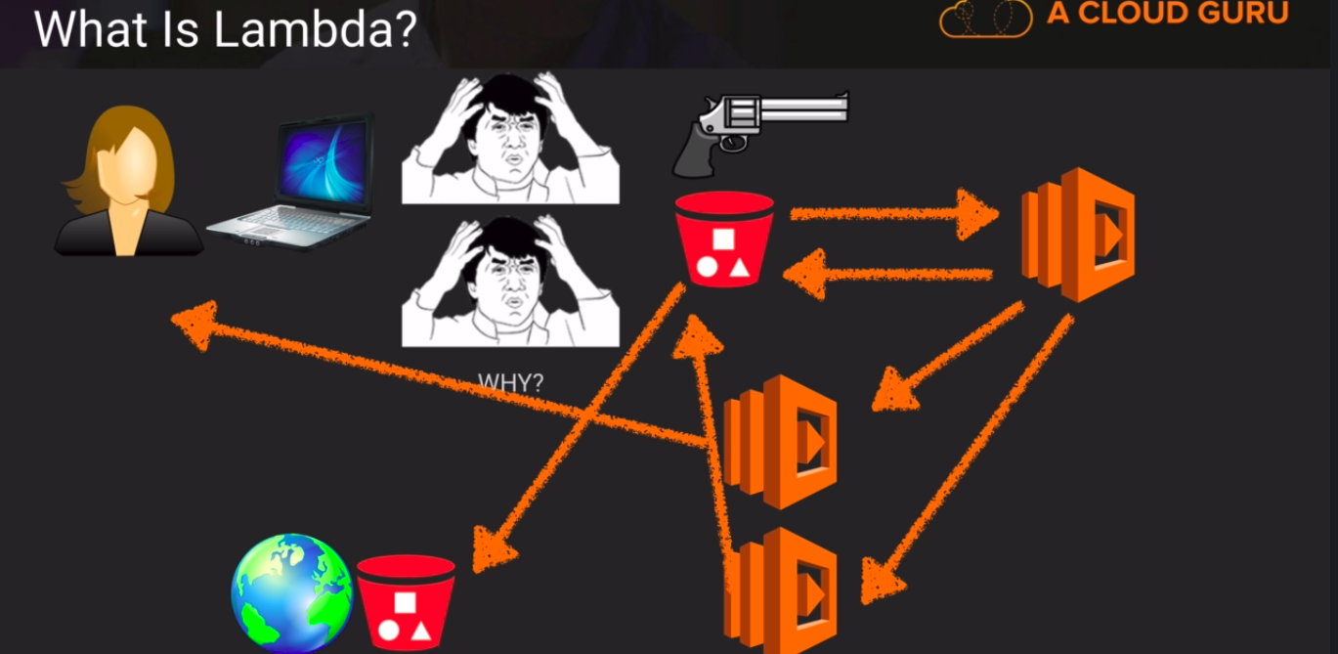
Lambda functions can call lambda functions
scaling up – increase specs in your pcs
scaling out – increase the pcs you have

Lambda Lab
- head over to lambda in AWS
- create a function

Lambda pricing
first million is free.
.20 per 1 million requests afterwards
Duration – time it begins running to when it finishes computation
.00001667 per gb-persecond
FUNCTION CANNOT RUN MORE THAN 5 MINUTES
THIS IS SERVERLESS

LAMBDA Lab – create a serverless website with an api gateway & lambda
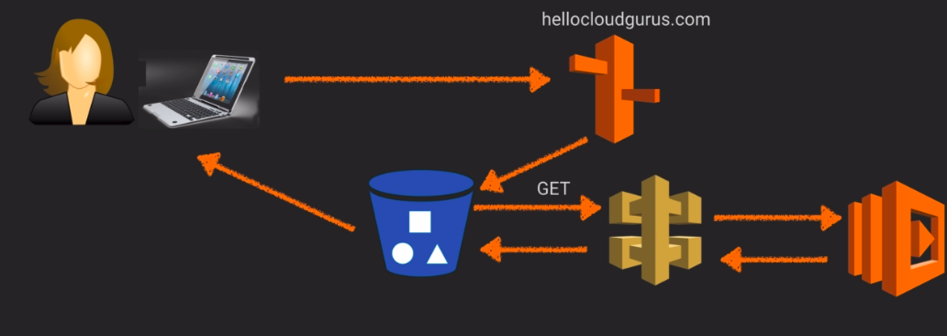

Using Poly to create an Alexa Skill
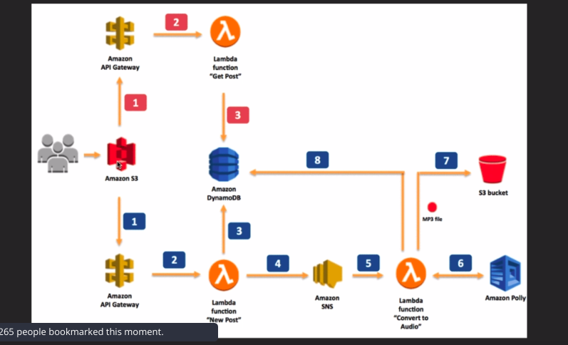
What is amazon SNS?
Simple notification service
What is amazon Poly?
Amazon Polly is a service that turns text into lifelike speech, allowing you to create applications that talk, and build entirely new categories of speech-enabled products
Poly lab
Here, all you do is writing some text, lambda will convert it to audio, save it to db.
A user can request to access it from the DB
SOP – same origin policy – prevents a website from making requests on behalf of another website
CORS – Cross origin resource sharing – allows you to make certain requests from one website to another website in the browser. Usually its by specifying a header

Build an Alexa Skill – Lab
Need to have the previous lab – serverless website and API done

EXAM QUESTIONS
- Reserved instances are available for multi-AZ deployments yes? YES
- Can you remove EBS volume that is an addition partition from a running instance? YES
- 4 levels of AWS support: Basic, Developer, business, enterprise
- Maximum response time for business level support is 1 hour
- All outbound traffic is allowed by default
- types of virtualization in ec2 – para-virtual(PV) and hardware virtual machine(HVM)
- types of aws storage gateways – gateway cached volumes, gateway stored volumes, gateway virtual tape library
- Amazon SNS has the following subscribers – Lambda, SQS, HTTPS, Email, SMS
- Create a placement group in an AZ to minimize latency
- Add volumes with provisioned IOPS , create a RAID 0, then create an RDS on an EC2 to maximize IOPS performance
- subnets can communicate with each other in a custom VPC by default
- You can transfer reserved instances from 1 AZ to another
- YOU CANNOT MONITOR MEMORY USAGE IN DEFAULT CLOUDWATCH DASHBOARD. A CUSTOM DASHBOARD MUST BE CREATE.
- For fixing auto-scaling that scales up and down randomly, change the cool-down timers and moify the amazon cloudwatch alarm period

Route53 - DNS
Dns maps FQDN to ip addresses
knpw ipv3
know ipv6

Top level domain names - .gov,.us,.eu,.com,.edu
Names are stored in IANA – root zone DB, has all top level domain names
Domain registrars - authority that can assign domain names
SOA – start of authority record – contains name of server, administrator of that zone, current version of the data file, default @ of seconds for TTL on resource records, STORES ALL THE OTHER RECORDS, THERE CAN ONLY BE 1 RECORD IN 1 DNS ZONE
NS record – nameserver records, these are used to direct traffic to the content dns server
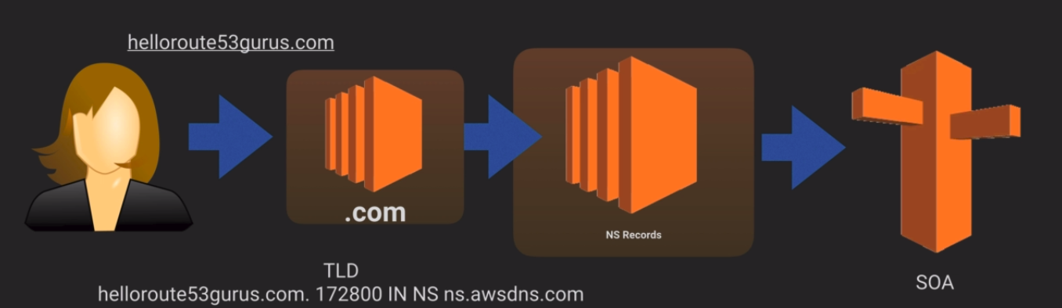
A Record – has the ipv4 address of the domain name
TTL – time to live, the lower the time, the easier for changes to propogated
CNAMES – canonical name – human readable names , can be used to resolve 1 domain name to another
ALIAS – unique to route53, map resource records to AWS services
THESE CAN BE USED TO POINT ZONE APEX RECORDS TO AWS SERVICES
ZONE APEX RECORD – naked domain names (e.g. http://acloud. guru) WHERE IS THE TOP LEVEL DOMAIN? (ex www.acloudguru .com)

Elastic load balancers only resolve to a DNS name
MX records – mail exchange records
PTR records – PTR means you own the domain name

DNS – lab
You can register a domain name for 12.00 per year
- register your domain name
- setup 2 machines for routing policies

Types of routing policies
- simple routing - you can only have 1 record with multiple ip addresses
- weighted routing – you specify a certain amount of requests go to a webserver/cluster/load-balancer
- latency-based routing – route traffic based on the lowest network latency for your user. The ec2 keeps a latency record then notifies route53 when requested. Route53 compares all these notifications and selects lowest latency
- failover routing – create an active/passive setup. Route53 monitors health of primary site using healthchecks
- geolocation routing – determines where to send the traffic based on user location
- multivalue answer routing – way to route traffic among many web servers, it tells the users DNS resolver how many servers are healthy and ready to process its requests,it automaticaly removes web server records that fail healthchecks

Simple routing Lab
- create 3 instances
- go to route 53 and select your hosted zone
- create a record set
  - set A records that maps either your TLD or a subdomain to values (these values are your ip addresses of your EC2/web server instances)
- access the website and that request will be sent to one of the servers specified

Weighted route policy lab
- create 3 instances
- go to route 53 and select your zone
- create a record set
  - under routing policy change to weighted. Specify your domains to certain Ips then give the weight value(1-unlimited) . Specify setID (string)
- access the website and that request will be sent to one of the servers specified

Latency based routing Lab
- create 3 instances
- go to route 53, select zone
- create a record set
  - Change routing policy to latency . Create record specifying domain to certain ips in a AZ.

Failover routing Lab
- create 3 instances
- go to route 53, select health checks
- configure health checks by monitoring endpoint,sum of other healthchecks, or a cloudwatch alarm
- for endpoint, specify the ip address, the hostname, and the path
- click on hosted zone
- create a record set
- Change routing policy to failover . Specify an ip address, setID to primary and associate it to the healthcheck. Specify another ip address, and setID to secondary with no healthcheck

geolocation routing Lab
- create 3 instances
- go to route 53, go to hosting zones
- configure policy to geolocation, specify your ip addresses, then set location to what you want, then setID to the location name.

multivalue routing
- create 3 instances
- go to route 53, go to hosting zones
- configure policy to multivalue, specify your ip addresses, then setID then create.

AWS VPC – Virtual Private Center
- This is just a virtual data center in the cloud , you have control lover ip adress range, creation of subnets, routing tables, and network gateways
- You can use NAT in the VPC as well. You can create a hardware VPC – hardware connection to your VPC
- Subnets wil only exist in 1 region. Each VPC can have multiple subnets.
  - /16 - /28 subnets
- By default, you only get 1 internet gateway.
- All EC2 instances have both public and private instances
- VPC Peering – have VPCs talk with one another, direct network routing. Done via routing table
  - Transitive peering – when one VPC bypasses central node to talk to another VPC, BELOW VPC B IS PEERED WITH VPC C TO TALK TO IT. IT CANNOT TALK WITH A TO GET TO C
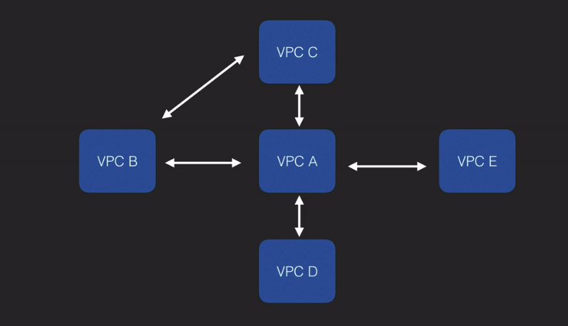
  - NO TRANSITIVE PEERING ALLOWED
- By default, new subnet route tables are associated with the main route table

Build your own VPC LAB
- head over to vpc tab in aws management console
- create a vpc according to your desired subnet length
- create 2 subnets with a length you specified and a region specified
  - 3 addresses are reserved for AWS
    - 10.0.0.1 – reserved by AWS for VPC router
    - 10.0.0.2 – reserved by AWS for DNS server (usually its the base of the vpc network range plus two
    - 10.0.0.4 – reserved by AWS for future use
- create an internet gateway. Attach VPC to this gateway
- create a new route table and enable internet access. Add 0.0.0.0 to add internet to the routes
- add 1 subnet to this route table to make it public. The other subnet will be private
- Make 1 subnet auto-assign public ipv4 addresses
- create 2 instances, each assigned to public and private subnets
- AT THE EC2 CONSOLE, youll see which one has an ipv4 address and that is publicly accessible

NAT Instances & NAT Gateways
NAT instances-
- VM’s that can act as NAT gateway and protect your local intranet from outside connectivity
- need autoscaling groups, much more administrative work thatn NAT gateway
NAT Gateway –
- can be created in VPC to server as NAT instances
- available 1 in each AZ

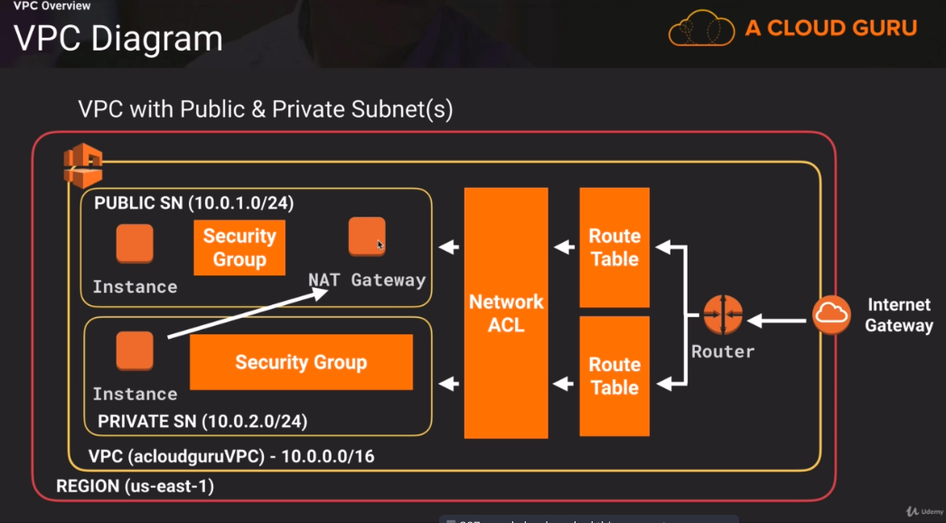

LAB
- setup a vpc with 2 instances
- go to awi marketplace and get – amzn-ami-vpc-nat-hvm
- on that instance, disable source and destination check
- in vpc, add a route to direct all internet traffic (0.0.0.0) to this nat instance

Remember, ec2 instance perform source and destination checks by defaults

NACL vs Security Groups (using the lab above)
ONLY ASSOCIATE 1 SUBNET TO 1 NETWORK ACLS
For ipv4 rules, do increments in 100
For ipv6 rules, do increments in 1 + previoud ipv4 rule
ephemeral ports – short lived transport protocol – used for tcp, udp as port assignment for a client communication
Network Access control list can be thought of as layered security. IT IS STATELESS MEANING YOU CAN BLOCK CERTAIN IP ADDRESSES. IN STATELESS FIREWALLS, YOU DONT CARE ABOUT THE CONTENT, YOU CARE ABOUT THE SOURCE AND DESTINATION

NACLs follow lowest priviledge allowed. DENY BY DEFAULT
INBOUND TRAFFIC – ONLY SPECIFY THE PORTS IN ACLS
OUTBOUND TRAFFIC – FOR HTTP TRAFFIC, SPECIFY EPHEMERAL PORTS

Load balancers need to be connected to 2 public subnets to work with custom VPCS.

VPC Flow logs
Feature to capture traffic to and from your network interfaces in your VPC. It uses cloudwatch logs. Sounds similar to Netflow logs
They can be created at the VPC, subnet, or network interface level.
Just useful for network statistics.
You cannot enable flow logs for a peer vpc that isnt in your account.
No tagging flow logs
no changing configuration with a flow log
Types of traffic not monitored
- traffic to amazon dns server
- traffic generated by windows instance
- traffic to apipa address
- dhcp traffic
- traffic to reserved ip address for vpc router

NAT vs Bastion servers
Bastions – NOT Jumpboxes – ssh into a box which can connect to private servers. ONLY USED FOR MANAGEMENT PURPOSES.
This is how NAT works except you dont need to connect to a machine to connect to a private server
Bastions can be made highly available by placing 1 in each subnet.
Bastions exist outside your security zone. It differs from jumpboxes in that its expected to be weak while a jumpbox is already a hardened device
Bastion provides secure administration access to ec2 instances while NAT provides internet traffic to private subnets.

VPC Endpoints.,
These are used by private instances to reach out to the internet or to certain aws services
- create an ec2 role and select s3 full access
- create a vpc endpoint for s3.
- Select your vpc, select your public subnet route table (main route table), select full access

EXAM QUESTIONS
- Can you conduct a vulnerability scan within your own VPC without alerting AWS first? No YOU MUST ALERT AWS
- Use RDS, DynamoDB, and elasticache to build a stateless web application
- There is a limit to 20 ec2 instances per region.
- VPCS with dedicated hosting tenancy cannot be changed to default hosting tenancy. A new VPC must be created.
- Name and valuie of text or binary objects in DynamoDB must not exceed 400Kb

AWS – Databases
There are both MySQL and NoSQL databases on AWS
Relational databases have keys, foreign keys, that are used to map relationships among values/objects.
Types of MySQL services: - OLTP
- SQL Server by Microsoft
- SQL server by Oracle
- MySQL – openSource server-bound
- Aurora – AWS proprietary
- PostGreSQL – open source
- MariaDB – open source

Non-relational DB -
collection – table
document – row
key value pairs - fields
Types:
- DynamoDB – Amazon NoSQL db, uses JSON
- Cassandra – high performance

Data Warehousing – OLAP used for business intellgience
Pull in large, complex data sets and used to do queries on data
Tools:
- Redshift
- Cognos
- jaspersoft
- sql server reporting services
- oracle hyperion
- SAP NetWeaver

OLTP vs OLAP
These differ in the queries you will run. OLTP analyzes 1 record, while OLAP analyzes large amount of records.
Online transaction process(OLTP)
ex. order num 12
You pull up rows of data such as name, date, address to,.e.g

Online analytics processing(OLAP)
Ex. net profit for digital radio company, pull in large records
run query on sum of radios sold, sold in each region
Data warehousing uses different architecture from a database and infrastructure perspective

Elasticache – web service that allows you to have in-memory cache in the cloud, improves performance by retrieving information from managed caches instead of relying on slow-disk-based databases
2 types
- Memcached
- Redis

RDS -Lab
Provision RDS instances and provision a web server
- launch an ec2 instance
- launch a rds instance
- use the files on acloudguru to provision the web server
- try to connect to the web server

More on DB backups, Multi-az, read-replicas
Automated backups – daily backups, these backups can be recovered within a retention period which is usually 1-35 days, backups can be restored down to a second
Backup data is stored in S3, and there is free storage relative to the size of your DB.
DB Snapshot – data save in time, always done manually, standalone recovery tool even if the original DB is destroyed
Restored backups will have different AWS endpoints
MySQls are encrypted at REST as a feature

Multi-AZ DB, these are synchronous– used for disaster recovery, when one fails, the DB will still be active since it is available in another AZ.
You have an exact copy of your prod db to another AZ. Any changes are synced over to the other replicas AGAIN, ONLY FOR DISASTER RECOVERY
Types of multi-az DBS:
- SQL server
- Oracle
- MySQL Server
- PostgreSQL
- MariaDB
- Aurora

READ-REPLICAS – used to improve DB performance ,
these are asynchronous
AGAIN, USED FOR SCALING, E.G. PERFORMANCE
There is a master DB, and the other DBS are read-replicas. All that happens is if any changes are made to the master DB, those changes can be read by the read-replicas DB
Types of multi-az DBS:
- MySQL Server
- PostgreSQL
- MariaDB
- Aurora

- Automated backups must be turned on for read-replicas!
- Max is 5 read-replicas.
- Read-replicas of read-replicas can be used
- Each read-replica has its own dns endpoint
- Read-replicas can be multi-az source DBs
- You can have read-replica is many regions

More on Dynamo DB – NoSQL Db
- Fast, flexible NoSQl DB that need consistent, millisec latency at any scale
- Stored on SSD
- Spread across 3 distinct data centres, 3 different facilities
- eventual consistency reads – faster performance, but data being served may not be up to date
- strongly consistency reads – slower, but all data being served is up to date. An API accessing a DB with strongly consistent reads will wait until a 200 code is served before accessing that record
Costs for Dynamo
Hourly.
Costs per I/O operations: more to write to DB than it is to read
.0065 per 10 writes per hour per month
.0065 per 10 reads per hour per month
Costs per storage: .25 per gb per month

Example
Your app performs 1 million writes and 1 million reads per day.
Stores 3GB of data
What is the cost?
1000000/24/360 = 11.6 writes per second
read and write capacity needed – 12 write capacity units
Cost = AWS cost per hour * capacity units needed * hours in use per day
write capacity unit cost = (.0065/10) * 12 * 24 = .18
write capacity unit cost = (.0065/50) * 12 * 24 = .03
Dynamo DB is much easier to scale due to push-button scaling

Redshift – Data warehousing
Usually, this is good for management that run reports
fast, powerful, fully managed, petabyte-scale data warehousing service
Cost range from .25/per hour to 1000 per terabyte per year
OLAP – online analytic processing
Go look at a record set and make reports, gain insight from this data
Configuring Redshift
- single node
  - receives queries and performs computation
- multinode
  - leader node and compute nodes:
    - leader node – manages client connections and receives queries
    - compute nodes – store data and perform computations, max size is 129 nodes

Columnar data storage – 10x faster
these require fewer I/O. These are faster because these only use queries in specified columns
Advanced compression – compression is faster because it compresses columns of the SAME DATA TYPE in that column. COMPRESSION IS DONE AUTOMATICALLY
Massive parallel processing – query loads are distributed meaning query performance is high
How so? Leader node takes the queries and distributes them across the compute nodes (similar like a load balancer)
Cost for Redshift
Cost is Node Hours = 1 unit * 1 node per hour
Ex. 3 nodes running per month = 3 nodes * 24 hrs in a day * 30 days = 2160. ONLY COMPUTE NODES WILL BE CHARGED
Costs for backup
costs for data transfer

Redshift security –
- encryption in transit and at rest.
- Redshift manages own keys(or through you via AWS KMS),
- ONLY SINGLY AZ
- snapshots can be restored to new AZ’s due to outages

Elasticache
GOOD FOR READ OPERATIONS ON DB’S
Service to deploy operate and scale in-memory cache, caches your db queries for example
again 2 types:
- Memcached – memory object caching system, doesn’t work with multiaz

- Redis – open source in memory key-value store, supports multi-az and master slave replication

Amazon Aurora
AWS DB announced in 2014
MySQL DB
Has 5 times better performance than other commercial DB’s
Start with 10GB, then scale up by 10GB up to 64TB
Scale cpus from 1 to 32 cpus and up to 244 gb of RAM
By default, your data is contained in each availability zone. DB is self-healing
Aurora can have up to 15 read-replicas
QUIZ NOTES FOR AWS SOLUTIONS ARCHITECT
- Automated backups are enabled by RDS
- RDS sql server storage cannot be increased
- Use IOPS over standard storage when DB does online transaction processing
- Microsoft SQL server DB with SQL Server express has a maximum storage of 10GB
- RDS-Aurora stores 6 copes of your data by default

AWS Application Services
Simple query service - SQS
web service that give you access to a message queue that can be used to store messages until a computer processes them.
Temp repo for messages until a computer processes them.
Ex.
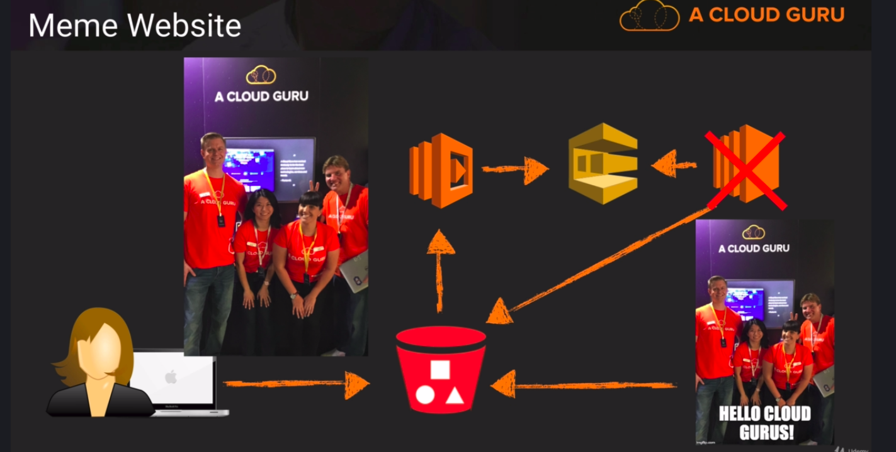
upload an image to an s3 bucket
it triggers a lambda function which sends this image to SQS
you encode the image with text using the sqs and stores it in the same bucket or another bucket
sqs assigns jobs and waits for new ones

examlpe 2
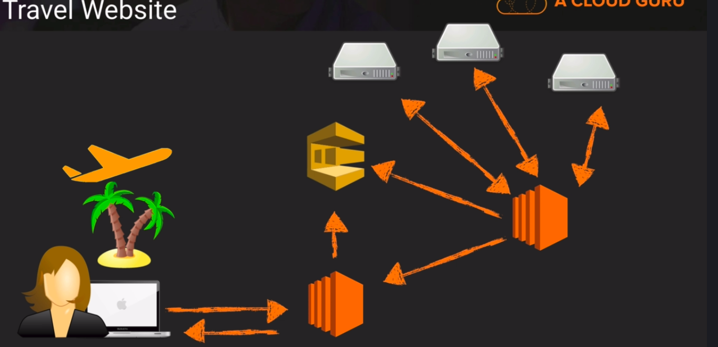
SQS can help with finding the lowest price for an airline flight

- SQS is a pull based system
- Messages can be kept from 1 min to 14 days
- it finds the lowest price, passes it off to ec2, then back to the users PC
  - invisibility timeout window – queues ALWAYS REMAIN IN SQS, min is 30 secs, max is 12 hours
- If user loses the query, it will remain in SQS
- SQS can scale
- it can hold up to 256 kb of text in any format
Queue types:
  - standard queue – unlimited transactions, guaranteed messages, no effort to make messages arrive in an order
  - FIFO queue – first in first out queue, support ordered queyes, limit of 300 messages per second
- SQS Long polling – way to retrieve messages from queues without constantly polling, it will return a message when the queue has a job to process
  - short polling polls queues even if nothing is the queues

Simple Workflow Service (SWS)
web service that makes it easy to coordinate work across distributed components
Some tasks can be media processing, media transcoding, analytics, business process workflows
Ex. take a media, spin up an ec2 instance, spin up aws media converter to wma, use ec2 instance to convert the media to wma, create an s3 bucket, store media file in that s3 bucket
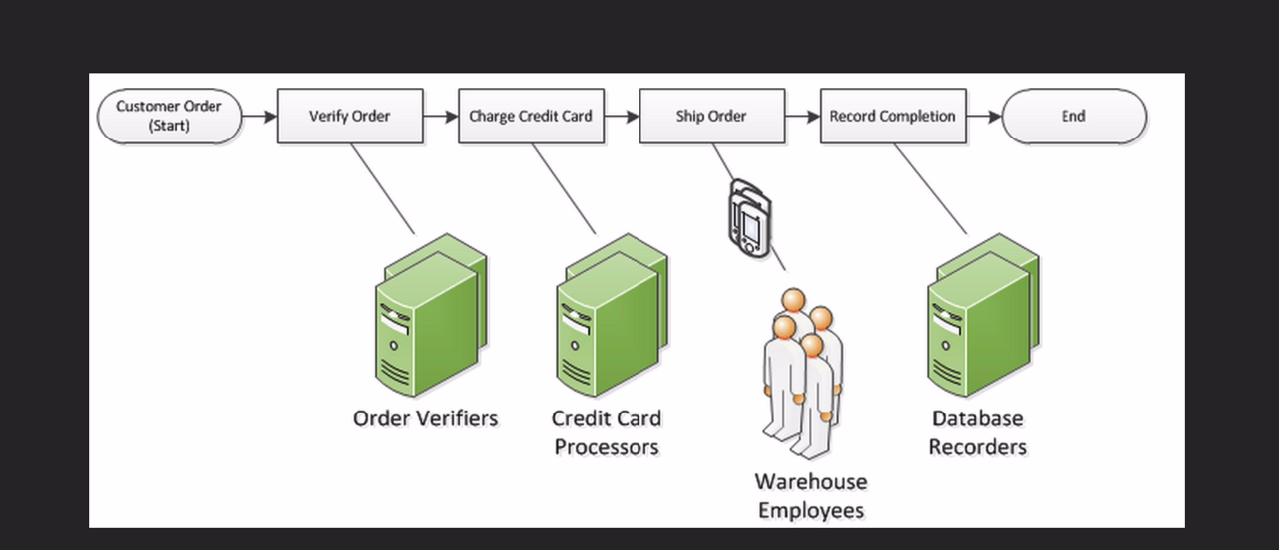
Follow this business process and workflow can be made to create this process. This example is amazon customers ordering something online.
SWS workers – interact with amazon workflows to get tasks, process tasks and return results
SWS decider – controls coordination of tasks
Both can run on AWS clouds, decider can see progress on the tasks and machines assign to swd workers SWS never assigns a task more than once while SQS , the task can be assigned more than once.
SWS domains – way to isolate many workflows, 1 domain can have set types, number of operations and task lists, use the AWS management console and registerdomain in SWF API
- Params are specified in Json
MAXIMUM WORKFLOW VALUE IS 1 YEAR

SWS vs SQS
SWS has task oriented API while SQS has message API
SWS assigns task only once while SQS assigns multiple times
SWS keeps track of everything while SQS does not
SWS USUALLY INVOLVES HUMAN INTERACTION

Simple Notification Service – (SNS)
web service that makes it easy to send and operate notifications. It is cost-effective, scalable and flexible.
- Deliver notifications by text,email, sqs queues
- can trigger lambda functions
- useful for notifying of autoscaling
- you group the recipients using “topics”. These are access points that allow targets to subscribe to the same notificaiton
  - useful for grouping together many devices such as iOS, Android, SMS
- all messages published are stored redundantly across multiple availability zones
- this is push based deliver
- simple APIS
- inexpensive
Elastic Transcoder
- Media transcoder in the cloud
- change it into different formats
- pay on the minutes you transcode and the resolution of how you transcode
Create a pipeline
s3 bucket stores media
lambda function is triggered to send it to the elastic transcoder
store new transcoded file into mp4 files

API Gateway
- managed service for developers to create and secure an API.
- Create the API to act as a front door for your applications
How does it work?
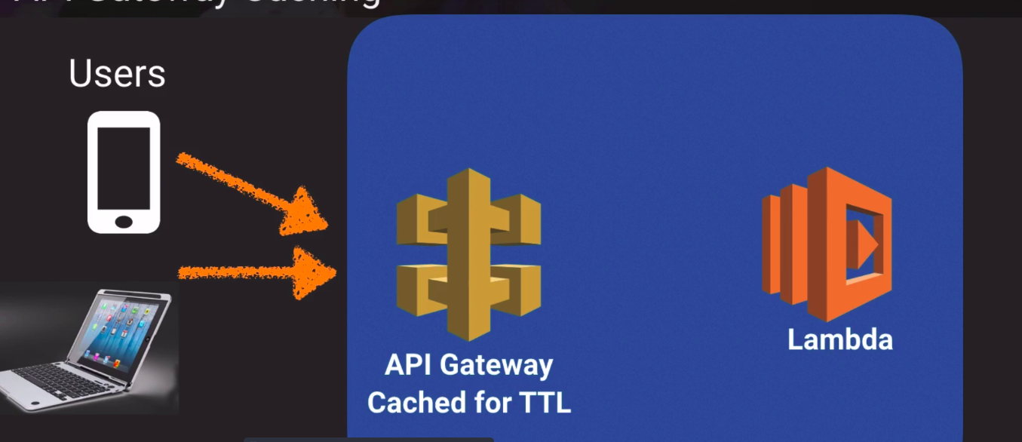
- You can cache responses to help users get a resource much faster
- API is low-cost, scales effortlessly, throttle requests
- Connect API gateway to cloudwatch
- use CORS to make cross origin requests
- If you get error “origin policy cannot be read at the remote resource. ENABLE CORS

Elastic map reduce – EMR
Managed Hadoop framework that makes it easy to process vast amounts of data across ec2 instances
EMR notebooks provide ad hoc querying and exploratory analysis

AWS Kinesis
- Streaming Data – data generated continuously usually in small sizes, think of purchases from online stores, stock prices, social network data , geospatial data
- platform to send receiving data to, way to analyze this streaming data
- 3 core services
  - kinesis streams – data is stored by 24 hours in shards, think of these as the various avenues, highways that are producing traffic, consists of shards (5 transactions per seconds)
  - kinesis firehouse – no SHARDS, data comes in and you can analyze it in the same area, no consumers to process this data needed,
  - kinesis analytics – you can run sql queries on data in the streams and in the firehouse, then store that data in s3,dbs, or elasticsearch

Example of Kinesis streams
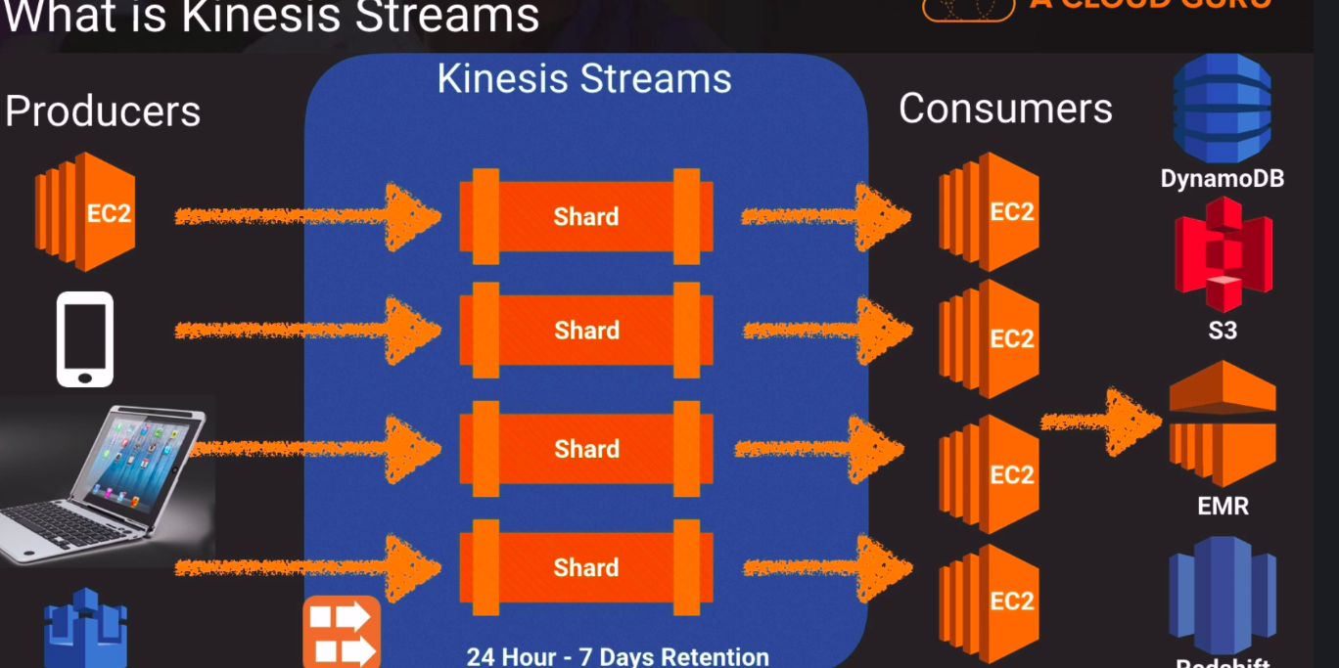
Example of kinesis firehouse

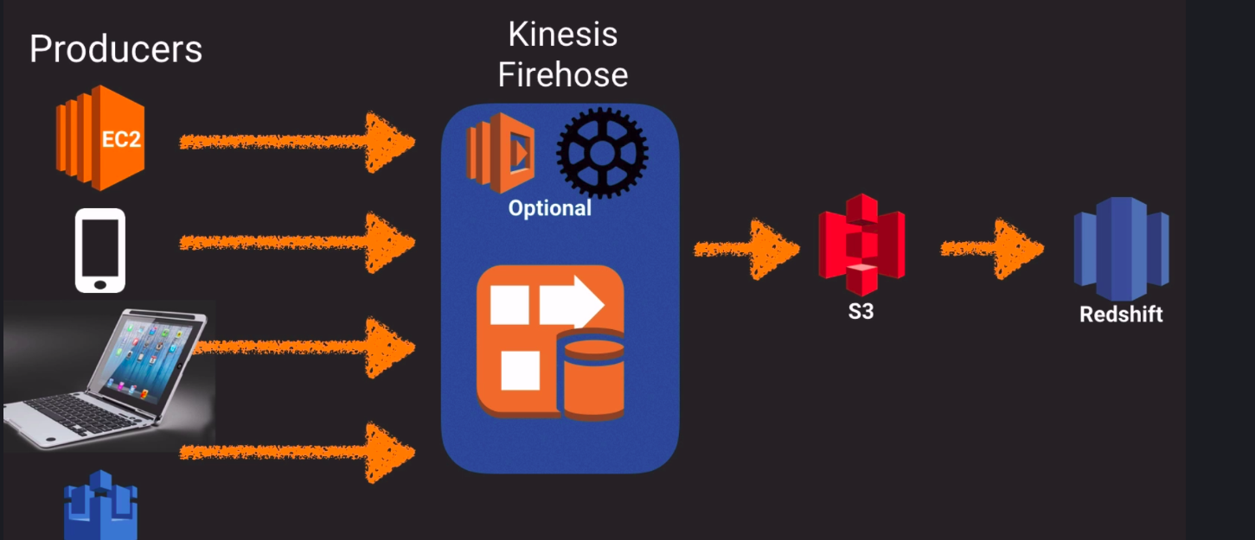

Example of Kinesis Analytics
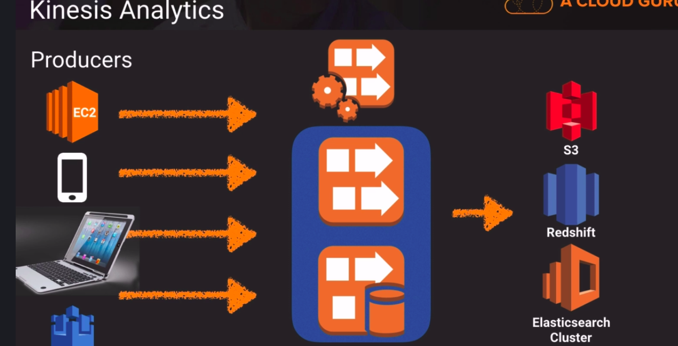
Kinesis Lab
Cloudformation template to create new stack of instances

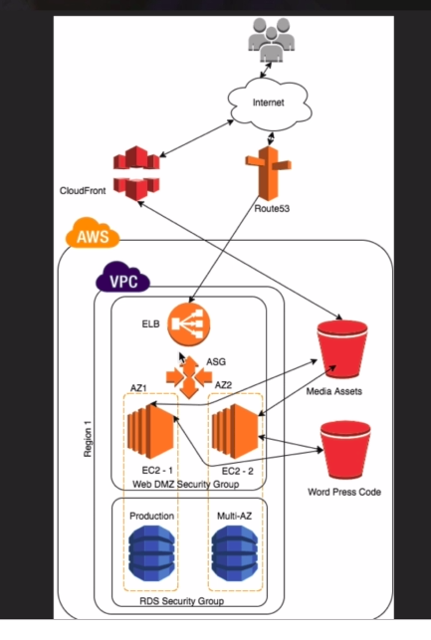

How the fault-tolerant website works:
- users will connect to cloudfront endpoints or to a domain name hosted on route53
- it will direct them to the media assets in a s3 bucket or a website hosted in a DMZ, these ec2 web servers are connected to a load balancer and an autoscaling group. They will server the website and related media assets.
- If a user logs in, their information will be logged into an RDS and all these services (except s3,cloudfront, and route53, are inside a VPC)

URL Rewrites – update url to point to cloudfront address
Cloudformation – launches your entire infrastructure as a script. THINK OF IT AS INFRASTRUCTURE AS CODE

EXAM QUESTIONS
- What is the underlying hypervisor for EC2? Xenserver
- Elastic beanstalk handles deployment of code – provisioning ec2 instances, load-balancing, auto-scaling, application health monitoring
- Redshift uses block size of 1024KB/1MB for its columnar storage
- Reducing EMR computation is done by reducing the input split size in the map reduce job, then adjust the simultaneous mapper tasks so that more tasks can be processed.
- SQS messages are invisible (visibilitytimeout ) from 1 hr to 12 hrs
- SQS doesnt keep track of all tasks or events in an application
- The owner is the identity and email address used to create the AWS account
- DBA Leads should ask dev team to code for strongly consistent reads when deplpying Dynamo DB

The Well Architected Framework
Architecting for the Cloud – best practices

Business benefits:
- no upfront infrastructure costs
- just-in-time provisions
- more efficient resource uses
- usage based costings
- reduced time to marketplace

Technical benefits:
- automation
- software architects
- auto-scaling
- proactive scaling
- better lifetime cycles - agile development
- improved testability
- disaster recovery and business continunuity
- overflow the traffic to the cloud

Building elasticity – using computing power when you need it, decreasing it when you dont
Design for failure – murphys Law use backups, multi-AZ, multi-Regional instances, have autoscaling on the ready,
Chaos engineering – designing for the worst
Decouple your components – think of SQS, build components that are not hardwired to another (e.g. database connected to only 1 web server. Connect it to the web server cluster
Implement elasticity
- scale during an interval
- scale when needed
- scale during a fixed interval
- proactive event scaling – launching new products, scale your supporting resources
- autoscaling based on demand – monitor usage of cpu, traffic and scale more resources when needed (and vice-versa)

Secure your applications

The Well Architected Framework
What is it?
It is a set of questions to evaluate how best your architecture is aligned to AWS best practices.

5 pillars of the Well-Architected Framework
- security
- reliability
- performance efficiency
- cost optimization
- operational excellence

5 pillars
- security
  - defense in depth – security at all the layers (e.g. NACL, security groups)
  - enable logs to trace attacks
  - automate response to security events(for brute forcing passwords → send SNS to you and lock the account)
  - automate security best practices ( password policy, harden your linux image)
  - Shared responsibility model – AWS handles physical and hardware security – YOU ARE RESPONSIBLE FOR SOFTWARE SECURITY AND HARDENING
  - AWS handles physical hardware, compute services, storage services, and database services
  - 4 main areas
    - data protection – organize and classify your data in areas such as publicly available, available to members of your organization, available to certain numbers, etc.
      - implement least privilege
      - encrypt data at transit and at rest
      - encrypt your data and rotate the keys on a schedule basis
      - logging wherever possible
      - versioning where possible
      - determine when to move data between regions in policies
      - use AWS ALB, EBS, S3, RDS
    - privilege management
      - only authorized personnel allowed to view/edit data
      - use of NACLs, security groups, and password management- password rotation policies, role based access controls
      - use AWS IAM, MFA
    - infrastructure protection -
      - RFID controls in place, lockable cabinets, (anything outside of the cloud)
      - using public/private subnets, private VPC’s
    - detective controls -
      - using AWS cloudtrail, cloudwatch, aws config, s3 bucket policy, amazon glacier
      - use IPS/IDS (e.g. snort)
- reliability
  - covers the ability of a system to recover from outages/disruptions and to aquire new resources to accommodate new demand
  - test your disaster recovery strategy and recovery procedures
  - Use Netflix’s Simian Army – different tools to test your aws infrastructure
  - automate recovery from failure
  - scale horizontally – adding more resources, replace 1 large resource with more smaller resources
  - 3 main areas
    - foundations
      - architect your infrastructure before building it out. Think out all the problems beforehand before implementing them
      - AWS handles most of the foundations for you
      - Be aware of the service limits
      - Identify service limits, escalation path for technical issues(use aws support),
    - change management
      - plan how to deal with changes (need more resources, outages, need less resources)
      - Use AWS cloudwatch, use AWS cloudtrail
    - failure management
      - Design with failure from the start! THINK OF NETFLIX.
      - Use AWS Cloudformation
- performance efficiency
  - how to use computing resources efficiently and maintain that as tech ecosphere evolves
  - server-less architecture
    - no servers to maintain
  - go global in minutes
    - use cloud formation
  - experiment more often
  - democratize advanced technologies
    - consume new technologies without having to build them
  - 4 main areas of performance efficiency:
    - compute
      - choosing the right kind of server (cpu number, ram size, )
      - adding and removing services when needing(auto-scaling, load balancers, Lambda function)
    - storage
      - storage depends on the most common factors which are: access method, patters of access, throughput required, frequency of access, frequency of update, availability constraints, durability constraints
    - database
      - depends on database consistency, availability, type (mysql vs nosql),
    - space-time trade-off
      - Computer science concept – spend more time to solve a problem using little space OR use more space to solve a problem in less time
        - ex. use RDS read replicas to lower read times to an app from a DB, use AWS Directconnect to lower network latency between HQ and your AWS Datacenter, or use cloudfront to host media as close to customer as possible
- cost optimization
  - reduce operational costs to a minimum. However, keep them at a minimum with just enough to run your business.
  - Add attributes(TAGS) to resources (ex. How much is each department spending)
  - used manages services to reduce cost of ownership
  - trade capital expense for operating expense
  - benefit from economies of scale
  - 4 main areas
    - matched supply and demand
      - align your resources with how much demand there is
        - Use auto-scaling to add demand when needed and remove when not needed
        - Use cloudwatch to log this demand
    - cost-effective resources
      - determine the correct key instance type
      - should I keep a large server with many RAM, or smaller servers with smaller ram
        - AWS reserved instances, Trusted Advisor
    - expenditure awareness
      - you are notified how much a resource costs to be deployed and the time to begin using it
      - use tags to allocate tags to a department
        - Use Cloudwatch and SNS
    - optimizing over time
      - be aware of new products in AWS to determine if one is better than what you use now.
      - Subscribe to the AWS blog and use Trusted Advisor
- operational excellence
  - includes operational practices and procedures to manage production workloads
  - automate change responses and execution
  - For repetitive tasks, automate it.
  - Align operation processes to business objectives (KPIS)
    - Collect metrics by using AWS cloudwatch to monitor them
  - make small, incremental changes
  - test for responses to unexpected events
  - Learn from operational failures and implement solutions to them
  - Keep documentation up to date
  - 3 best areas:
    - preparation -
      - prepare for operational excellence
      - Use checklists, runbooks – operations guidance for op teams to perform daily tasks,
      - keep documentation up to date
      - Use playbooks - guidance for unexpected events, includes disaster recovery plan, escalation paths, stakeholder notifications
        - Use Cloudformation, AWS Auto-scaling, aws config, tagging
    - Operations
      - changes should be small, they should be reviewed, and operations should be manageable on a routine basis, make standards!
      - Integrate CI/CD pipelines, make standards for testing,
      - automate changes, and recovery anywhere and everywhere where you can.
      - Automate monitoring
        - Use AWS CodeCommit, AWS Codedeploy and AWS CodePipeline
    - Responses
      - automate responses to outages. Use runbooks and playbooks wherever needed to keep outages to a minimum. It should notify stakeholders when there is a change/outage. Keep them updated with progress to restoration.
        - Use AWS Cloudwatch, Amazon SNS

General design principles
- stop guessing your capacity needs
- test systems at production scale (using cloudFormation)
- Automate so you can experiment with your architecture much faster
- allow for evolutionary architectures
- data-driven architectures – logging your infrastructure to gain insight on how to improve your architecture
- improve through game days – simulate events in production, (e.g. prepping for black friday, new years sale, etc)

Other Items
Elastic map reduce – used for big data processing
Anything for consuming big data → think of Kinesis
EBS backed vs instance store -
- ebs backed volumes are persistent
- ephemeral storage is not persistent
- ebs volumes can be attached to other ec2 instances
- store data long-term in EBS backed

OpsWorks – orchestration service that uses Chef
Chef – way to organize recipes to maintain a consistent state
Elastic transcoder – media transcoding
SWF actors -
- workflow starters – app that initiates a workflows , (ex ecom website)
- deciders - control flow of activity tasks
- activity workers – carry out the activity tasks
Query ec2 metadata – curl apipa address + latest/meta-data

AWS Organizations Consolidated billing
account management service to consolidate multiple AWS accounts into an organization
(e.g. useful for departments needing their own AWS accounts)
features are :
- consolidated billing
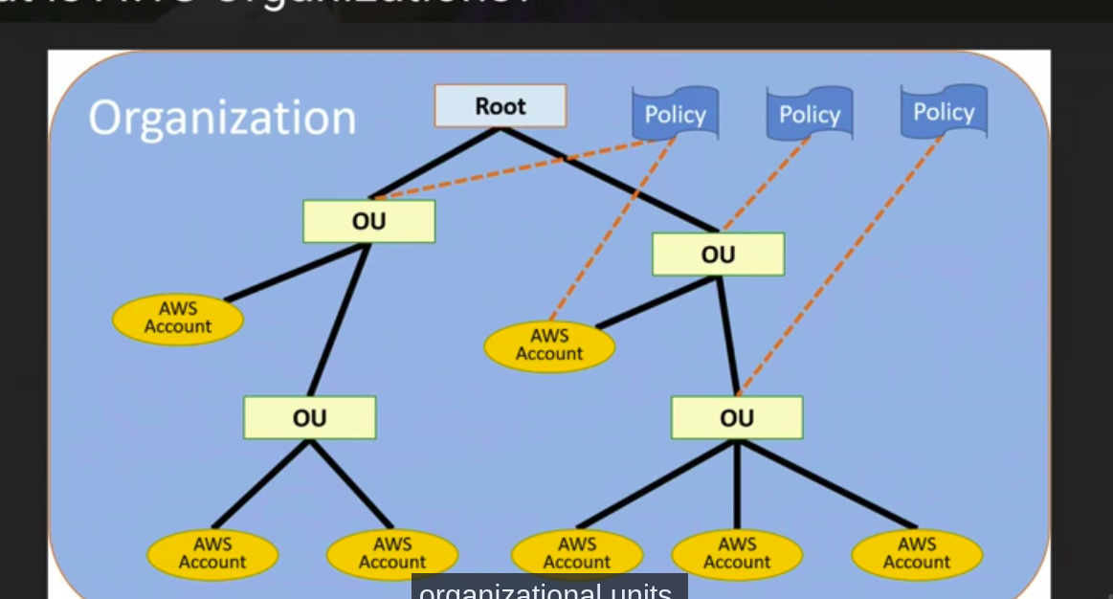
Organization units – tier controlling the AWS accounts, a policy can be applied to each organizational units

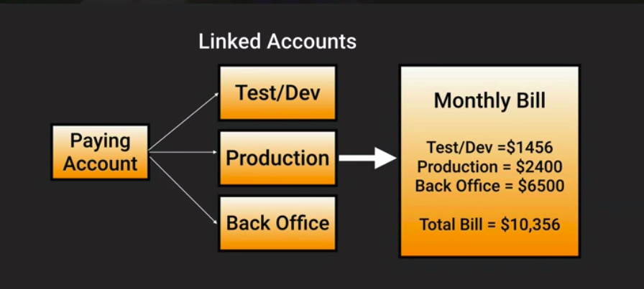
Advantages are: 1 bill per account, lower cost for the more you spend
Example: My company uses 600Gb, production uses 900gb and back office uses 500GB
Costing is as follows:
- first 1Tb - .03 per gb
- next 49Tb - .0295 per gb
- next 450Tb - .0290 per gb
- next 500Tb - .0285 per gb
- next 4000Tb - .0280 per gb
- over 5000Tb - .0275 per gb
WITHOUT CONSOLIDATED BILLING, TOTAL IS
600 x .03 = 18
900 * .03 = 27
500 * .03 = 15
Total: 60 for 2TB of storage

WITH CONSOLIDATED BILLING, TOTAL IS
1Tb x .03 = 30
1tB & .0295 = 29.50
TOTAL = 59.50

best practices
use MFA
no running instances on paying accounts20 linked accounts only
use billing alerts, you can create billing alerts per each account or the entire account
use cloudtrail per aws account and enabled per region
consolidate logs in an s3 bucket

Policies can be applied to individual accounts. Ex. (limit cost.)
Service Control policies (SCPS) – control service use, Allow or deny individual services in an account (e.g. deny kinesis to HR)
Automate account creation
More on cross-account access
Identify your account numbers
create a group in IAM – developer
create a user in IAM – developer
log in to production
create read-write-app-bucket policy
create updateAPp cross account role
apply new policy to the account
create new inline policy and apply to developer group
Inline policies only apply to a single user, group or role
login as john and switch accounts
YOU CAN ALLOW A USER FROM 1 ACCOUNT TO LOGIN AND MANAGE RESOURCES FROM ANOTHER ACCOUNT

More on tagging and resource groups
Tags – key-value pairs attached to AWS resources
- these can be inherited (auto-scaling)
- these are just metadata
Resource groups – groups resources together using the tags assigned to them
contain info such as:
- region, name, healthchecks
- 2 types resource groups
  - classic – see all your ec2 instances and see who they belong to
  - systems manager – see all services and instances, and perform actions wherever needed

More on VPC Peering
Its a connection between 2 vpcs – think of it as a t1/wan connection
THEY MUST BE WITHIN A SINGLE REGION
There is no single point of failure – connection will always be on
There is no bandwidth bottleneck
VPCS cannot be in the same subnet! Must have different subnets
Transitive peering isn’t supported – VPC A ↔ VPC B ↔ VPC C
VPC A MACHINES CANNOT CONNECT TO VPC C MACHINES, THEY MUST BE PEERED
VPC PEERING IS 1-TO-1

More on DirectConnect
Dedicated network connection from your data center to AWS
benefits:
- lower costs
- increase reliability
- increase bandwidth to aws
AWS Directconnect vs VPN – it doesn't use the internet, its a private connection to AWS
Rates
10gb/sec or 1gbps
Uses ethernet vlan trunking

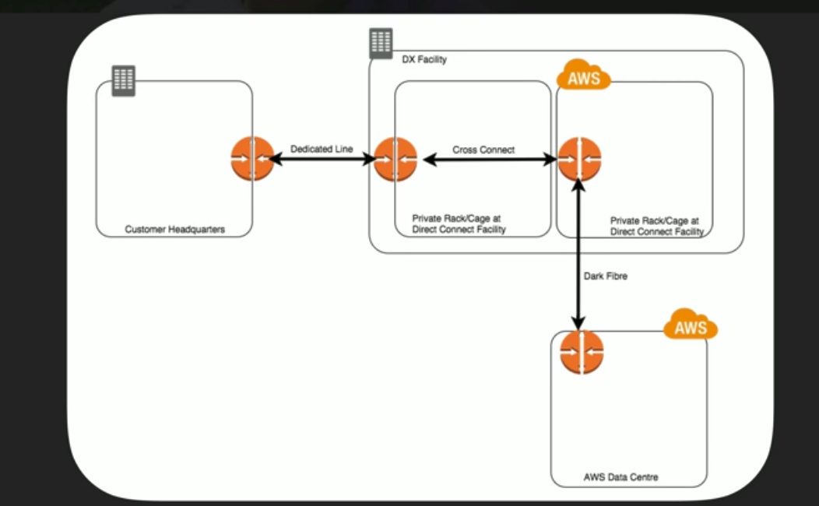
Encryption on the DirectConnect takes a while! Use a VPN

More on the Security Token Service (STS)
grants users limited and temporary access to aws resources
3 sources
- federation
  - uses SAML
  - grants temp access based off AD credentials
  - single sign in allows users to login to aws console
- federatation with mobile apps
  - use facebook/openID providers to login
- cross-account access
  - lets users use 1 aws account to access resources in another
Federation – join a list of users in one domain to another domain
Identity broker – service that will take an identity from point A and join it to point B
Identity store – services like AD, facebook
identites – a user of a service like FB

Scenario
hosting a company website in an ec2 in a vpc
Users must login to the site against an AD
Your vpc is connected to your company HQ via ipsec vpn
Once logged in, user can only access the s3 bucket

What is the setup?
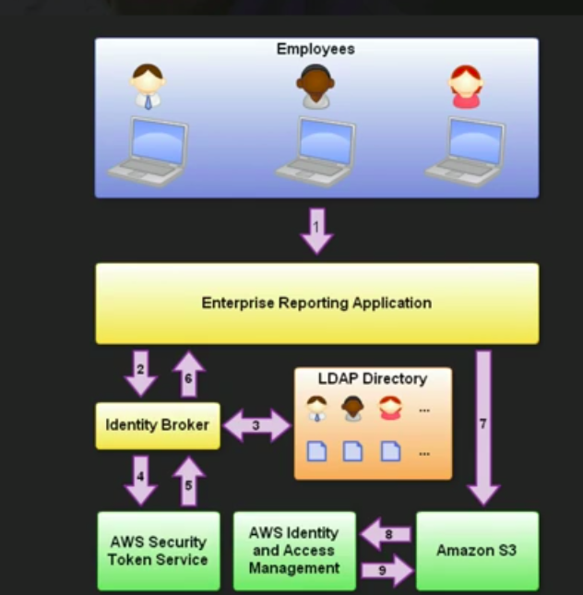

1. users login
2. credentials to go identity broker
3. identity broker checks ldap directory and ensures its correct
4. identity broker calls aws STS to get federated token using a functioncall that includes an IAM policy and a duration and another policy that specifies the permissions to be granted
5. STS confirms user has the policy to generate new tokens and returns access key, secret access key, token, and a duration
6. entity broker returns security credentials to the enterprise reporting application
7. enterprise reporitng application makes a call to s3
8. s3 uses credentials to verify with AWS IAM
9. IAM returns response to s3
How to federate AD with AWS Console
- user signs in on a website
- they are prompted for their ad username and password
- browser receives SAML assertion in the form of a response from ADFS
- browsers posts the SAML to the AWS sign-in endpoint for SAML. Sign in uses an API to request temp security credentials, then constructs a sign in url for the AWS management console
- bobs browsers receives the sign in url and is directed to the console
Note this all happens fast without the user noticing.
YOU CAN AUTHENTICATE WITH SAML AND AD TO THE AWS CONSOLE
YOU AUTHENTICATE TO AD FIRST, THEN GET THE TEMP CREDENTIAL next.

AWS Workspaces
Cloud replacement for traditional desktop
Itll run windows, linux, e.g.
- User can connect to a workspace from any device and login with given credentials by an administrator
- windows 7 can personalize their settings
- use group policy to lock everything down
- workspaces are persistent. Always up!
- All data on the D drive is backed up every 12 hours
- no AWS account needed to login

More on ECS – What is Docker?
Elastic Container Service – container service in AWS
typical application stack → guest OS(linux), dependencies(apache), application(facebook), VM
Docker will wrap up all dependencies which means the environment will be all the same
Docker will ship your code, highly-scalable, and know your code will run.
Great way to run distributed applications
Container – package code, configuration and dependencies which ensures application will run
Virtualization vs Containerization
Vm contains the entire OS, dependencies, and application, it uses 80% to the OS mainly
Container – only contain dependencies and application, no need for OS
main differences – containers use less space, much easier to package and ship
ESCAPE FROM DEPENDENCY HELL
Better way for microservices – makes code very portable

Docker image – basics for a docker container – Similar to an iso – contains files needed to boot a container
Docker container – contains dependencies and an application
Layers – Union File System – layers in a docker image – this combines code(older layer) in a container with possible new code(new layer) in the future (union) and uses the combined files in the container. Devs push out new layers and makes it much easier
DockerFile – text document that contains all commands a user could call on the command line to assemble an image. THE BUILD INSTRUCTIONS
Docker daemon – engine – runs the container
Docker client – your console to control running containers
Docker registries – docker hub – holding all docker images

Amazon ECS – highly scalable, fast, container managemenet service to run, stop containers. All centralized container management service for amazon ec2

The anatomy of Amazon ECS
Regional service to be used in 1 or more AZ’s. You can manage ETL – extract transform load – database functions. You can scale or descale and manage clusters
Easy way to create and manage microservices
Images are stored in Amazon ECR – elastic container registry
Task definition – text files in json format that describe on or more containers that form your application, describes a docker container in a JSON format, LIKE CLOUDFORMATION TEMPLATE
specifies networking mode to use in containers
commands if it fails, when it starts, what volumes to attach
ECS services are auto-scaling groups for ECS
ECS Clusters – logical group of containers with tasks. They are region-specific, containers can only be part of 1 cluster at a time,
Service Scheduler – ensures specific number of tasks are constantly running
Customer scheduler – create your own schedulers
Container agent – allows containers to connect to a cluster , preinstalled on amazon ecs amis, will not work with Windows
ECS instances use IAM roles. Security groups attach at the OS level, not the task or container level
Limits – 1000 clusters per region
Hard limits- one LB per service, 1000 tasks per service

AWS Shield – managed DDOS provider owned by Amazon

Amazon Athena – serverless interactive query service – analyze data in S3 using amazon SQL

Amazon Neptune - fast, reliable, fully managed graph database service that makes it easy to build and run applications that work with highly connected datasets, Property Graph and W3C's RDF, and their respective query languages Apache TinkerPop Gremlin and SPARQL,

Amazon redshift spectrum – allow columnar storage users to query arbitrary files stored in s3

Cloudwatch agent – allows you to collect metrics and logs from amazon ec2 instances.

Amazon Cognito – simple, secure – user sign-up, sign in and access control – good for enterprise identity and authentication

Stateless web servers – any response from the server is independent of any sort of state. Stateless uses requests and response

Redis – open source, in-memory data structure store used as a DB, cache and message broker
Amazon elasticache – in-memory data store that provides millisecond latency to power appliations

Route origin authorization (ROA) – document that you can create through an regional internet registry. Afterwards, this authorizes amazon to advertise an address range under a specific AS number

S3 has no onsite data encryption pnly client and server side encryption

RDS Enhanced monitoring provides real time metrics for the operating system \

Amazon redshift enhanced vpc routing – all copy and unload traffic between your cluster and data repos go through your amazon vpc

Spot instances terminated by Amazon ecs (due to current price being higher than what you bid on), you wont be charged for it.

More on Amazon API gateway – provides throttling limits by global and service call. Caching can be added to your gateway to improve performance and reduce the traffic sent back to your end

Use signed cookies to control who can access the private files in your Cloudfront distribution.
Use signed cookies when you want to provide access to multiple restricted files or you dont want to change your current URLs

EBS volumes can be used as normal while a snapshot is in progress.
Amazon MQ – message queue – managed message broker service – useful for applications that already have a messaging feature.

KMS API will allow an application to encrypt all data or individual user data before writing it to a disk.

More on Amazon Dynamo db
partition key – part of a tables primary key, determine logical partitions in which a tables data is stored, affects the physical partition design principle – ALWAYS USE THE RATION OF PARTITION KEY VALUES TO THE TOTAL NUMBER OF PARTION KEY VALUES INCREASES.
Use partition keys with high-cardinality attributes, which have a large number of distinct values for each item

Redis and Elasticache question – authenticating cloud engineers and securing session data in the portal.
Authenticate users using redis AUTH by creating a new redis cluster with both –transit-encryption-enabled and –auth-token parameters enabled.

AWS lambda deployment configuration types:
canary – traffic is shifted in 2 increment- define a percentage of traffic shifted to the updated lambda function
linear – shift traffic in equal increments in equal number of minutes

Perfect forward secrecy is used with cloudfront and elastic load balancing -

Snowball edge has 83tb of usable storage while snowball only has 72 tb

Pilot light – minimal backup infrastructure is running, servers as a DR tactic

Amazon switches the canoical name should an amazon primary RDS need to fail over to a secondary

SNS and SQS do not perform asynchronous function calls

